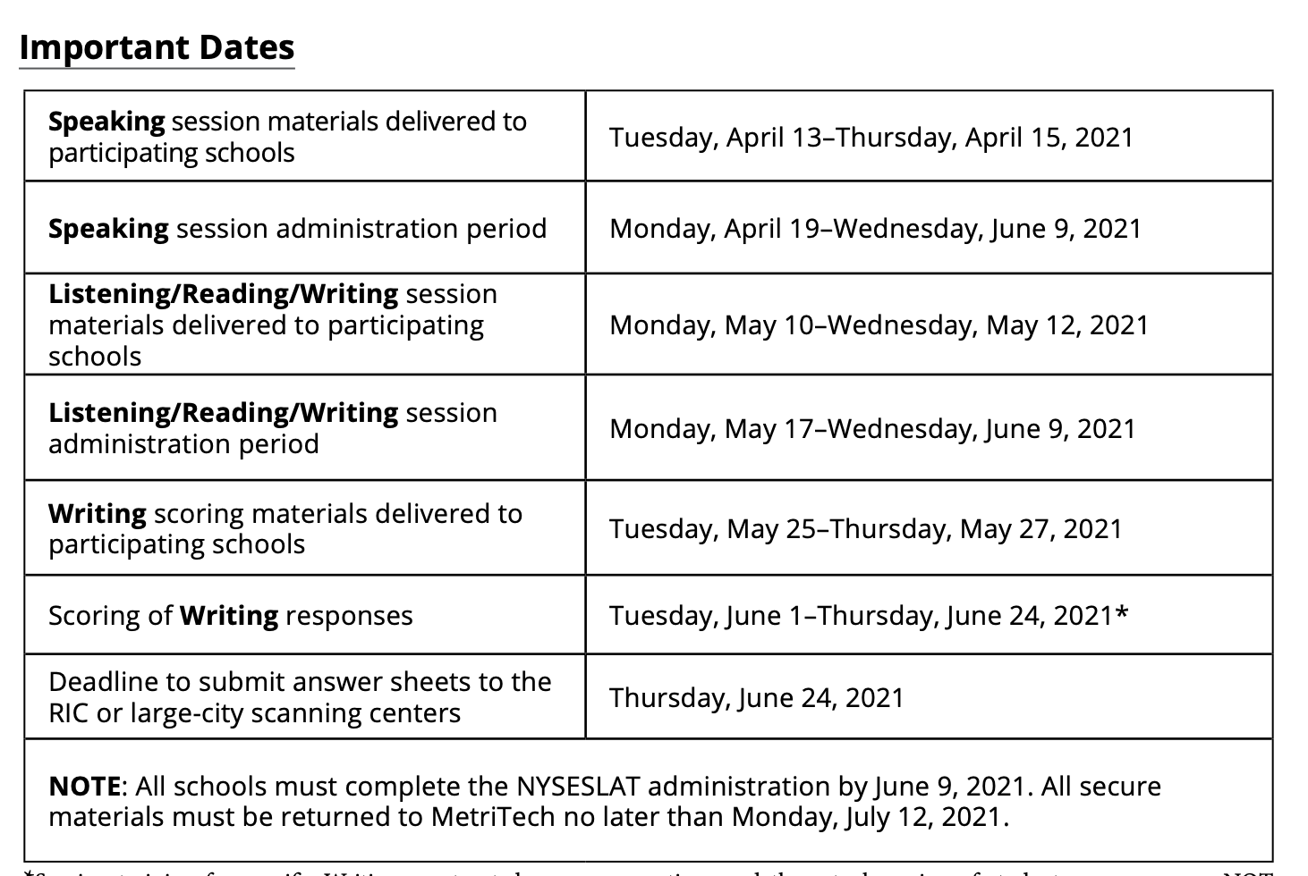

Remember: Speaking must be taken individually
(ALL other sessions, students can be tested in small groups)

NYSESLAT 2021, SPEAKING ONLY
 | (Monday  5/3) | (Tuesday  5/4) | WEDNESDAY  5/5  FIRST DAY for Blended | THURSDAY  5/6 | FRIDAY  5/7
Period 1
(8:00-8:45)
Period 2  (8:45-9:30) |  |  | Samir Acosta  Sadam Alsoufi | Daysha Alcantara  Liza Hossain | Liliana Rivas-Aquino  Yoel Gonzalez-Pimental
Period 3  (9:30-10:15) |  |  | Kazi Siddique | Malak Abiah | Rolando Gonzalez-Ruiz  Jonathan Manzueta-Melo
Period 4  (10:15-11:00) |  |  | Margie Parra  Marjerie Lopez Frias | Saylenis Abreu Rojas  Robert Vidal
Period 5
(11:05-11:50)
Period 6
(11:55-12:50)
Period 7
(12:50-1:25)
Period 8
(1:30-2:00)

NYSESLAT 2021, SPEAKING ONLY
 | Monday  5/10 | Tuesday  5/11 | WEDNESDAY  5/12 | THURSDAY  5/13 | FRIDAY  5/14
Period 1  (8:00-8:45) | Administer Speaking |  |  | Administer Speaking
Period 2  (8:45-9:30) | to any students  who were absent | Wilmer Rivas Aquino  Ahmed Abiah | Hennessy Molina  Sahar Abiah | Make-ups
Period 3  (9:30-10:15) | last week | Hade Acosta Dominguez  Dion Crisanto | Reina Manzueta  Neyllanie Smith
Period 4  (10:15-11:00) |  | Yadiel Alexander Correa
Period 5
(11:05-11:50)
Period 6
(11:55-12:50)

Period 7
(12:50-1:25)

Period 8
(1:30-2:00)

ALL REMOTE STUDENTS (in green) will take 2 sessions per day IN ORDER.
They will take all of the exam sessions individually.

DAY 1 for K: Speaking and Listening
DAY 2 for K: Reading and Writing

DAY 1 for Grade Bands 1-2, 3-4, 5-6: Speaking and Session 1 (L/R/W)
DAY 2 for Grade Bands 1-2, 3-4, 5-6: Session 2 and Session 3 (L/R/W)

Remember: Speaking must be taken individually
ALL other sessions, students can be tested in small groups

*Blended students may take one session per day.
Blended students will take L/R/W sessions in small groups of 6 or fewer.

NYSESLAT 2021, SPEAKING AND Listening, Reading and Writing
Remote students highlighted in green | Monday  5/17  FIRST DAY for L/R/W | Tuesday  5/18 | WEDNESDAY  5/19 | THURSDAY  5/20 | FRIDAY  5/21
Period 1
(8:00-8:45)
Period 2  (8:45-9:30) |  | Endri Rodriguez  2nd Grade Day 1 | Endri Rodriguez  2nd Grade Day 2 | Stiven Rivas  2nd Grade Day 1 | Make-ups
Period 3  (9:30-10:15) |  | Speaking and Session 1 | Sessions 2 and 3 | Speaking and Session 1
Period 4  (10:15-11:00) |  | Group A  SListening | Group B  Session 1 | Group C  Session 1
Period 5
(11:05-11:50)
Period 6  (11:55-12:50) |  |  | Group A  Reading | Group B  Session 2
Period 7
(12:50-1:25)

Period 8
(1:30-2:00)

NYSESLAT 2021, SPEAKING AND Listening, Reading and Writing
 | Monday  5/24 | Tuesday  5/25 | WEDNESDAY  5/26 | THURSDAY  5/27 | FRIDAY  5/28
Period 1
(8:00-8:45)
Period 2  (8:45-9:30) |  | Stivan Rivas  2nd Grade Day 2 | Jesus Martinez Perez  3rd Grade Day 1 | Jesus Martinez Perez  3rd Grade Day 2 | Make-ups
Period 3  (9:30-10:15) |  | Sessions 2 and 3 | Speaking and Session 1 | Sessions 2 and 3
Period 4  (10:15-11:00) |  | Group D  Session 1 | Group E  Session 1 | Group A  Writing
Period 5
(11:05-11:50)
Period 6  (11:55-12:50) |  | Group B  Session 3 | Group C  Session 2 | Group D  Session 2
Period 7
(12:50-1:25)

Period 8
(1:30-2:00)

NYSESLAT 2021, SPEAKING AND Listening, Reading and Writing
 | (Monday  5/31) | Tuesday  6/1 | WEDNESDAY  6/2 | THURSDAY  6/3 | FRIDAY  6/4
Period 1
(8:00-8:45)
Period 2  (8:45-9:30) |  | Enny Mendoza  5th Grade Day 1 | Enny Mendoza  5th Grade Day 2 | Tanisha Noor  5th Grade Day 1 | Tanisha Noor  5th Grade Day 2
Period 3  (9:30-10:15) |  | Speaking and Session 1 | Sessions 2 and 3
Period 4  (10:15-11:00) |  | Group E  Session 2 | Group C  Session 3 | Group E  Session 3 | Group D  Session 3
Period 5
(11:05-11:50)
Period 6  (11:55-12:50) |  | Make-ups | Make-ups | Make-ups | Make-ups
Period 7
(12:50-1:25)

Period 8
(1:30-2:00)

NYSESLAT 2021, SPEAKING AND Listening, Reading and Writing
 | Monday  6/7 | Tuesday  6/8 | WEDNESDAY  6/9  LAST DAY of administration
Period 1  (8:00-8:45) |  |  |  | Scoring the Writing can begin on 6/1
Period 2  (8:45-9:30) | Make-ups | Make-ups | Make-ups | You may score the writing until 6/24 | 6/24: LAST day to submit (scan) answer documents
Period 3
(9:30-10:15)
Period 4
(10:15-11:00)
Period 5
(11:05-11:50)
Period 6
(11:55-12:50)

Period 7
(12:50-1:25)

Period 8  (1:30-2:00) |  |  | ----------------------

Group A: Kindergarten

Samir Acosta(Castro, 0D2, Remote, LEP: E) EN for now*
Kazi Siddique (Dublin, 0AX Blended LEP: Y) BG Tested 10/21/20
Sadam Alsoufi (0AW, Chambers, Officially Blended, but Remote LEP: Y) AR Tested 10/21/20
Margie Parra (Dublin, Blended 0AX LEP: Y) TR Tested 12/22/20
Marjerie Lopez Frias (0AX, Blended, Dublin LEP: Y) Tested 10/20/20

Group B: 1st and 2nd Grade

Daysha Alcantara (Cordero, 1AV LEP: Y)
Liza Hossain EM (Harris, 1AT LEP: Y) BG
Malak Abiah (Jenkins, 2AQ LEP: Y) AR
Saylenis Abreu Rojas (Jenkins, 2AQ) EN LEP: E,
Robert Vidal M**IEP (Hernandez, 2BR LEP: Y)
Liliana Rivas-Aquino E (Hernandez, 2AR LEP: Y)

Group C: 3rd and 4th Grade

Jonathan Manzueta-Melo (Waymer, 3D6 LEP: Y)
Yoel Gonzalez-Pimental (Waymer, 3AO LEP: Y)
Rolando Gonzalez-Ruiz T (Waymer, Blended, 3AO LEP: Y)
Hade Acosta Dominguez (Williams, Remote, 4D6, RMT LEP: Y)

Group D: 3rd and 4th Grade
Dion Crisanto (Boyce, 4D5 LEP: Y)
Yadiel Alexander Correa (Boyce, 4D5 LEP: Y)
Hennessy Molina **IEP (Haddad, 4D7, RMT LEP: Y)
Ahmed Abiah T (Boyce, 4AN LEP: Y) AR*
Wilmer Rivas Aquino (Boyce, 4AN LEP: Y)

Group E: 5th Grade

Sahar Abiah T (5AH LEP: Y) AR
Reina Cristina Manzueta (5D6 LEP: Y)
Neyllanie Smith (5D6 LEP: Y)

