Over 30 ESL Strategies You Can Use Right Now in Your Classroom
written and compiled by Jason Taruskin
Key:
ENL = English as a New Language (this is what ESL will now be called in NYC)
There are 5 levels: Entering (beginning), Emerging (low intermediate), Transitioning (high intermediate), Expanding (advanced), and Commanding (tested out/proficient)
ESL = English as a Second Language

Stand-alone ENL = usually pull-out, a lesson taught separately from the curriculum in the ELL’s home class
Integrated ENL = usually push-in, the same lesson that is being taught in the ELL’s home class

ENL (ESL) is a program
ELL= English Language Learner (an ELL is a student; plural: ELLs)

L1= their first/native language
L2= their second language (presumably English)

BICS= Basic Interpersonal Communication Skills
CALP = Cognitive Academic Language Proficiency (“school language”/academic language)

TPR = Total Physical Response - a language-learning approach based on the relationship between language and its physical representation or execution; emphasizes the use of physical activity for increasing meaningful learning opportunities and language retention; a TPR lesson involves a detailed series of consecutive actions accompanied by a series of commands or instructions given by the teacher while students respond by listening and performing the appropriate actions

LEP: Limited English Proficient - a student who is not fully English proficient, speaks a language other than English at home, and does not demonstrate English language skills of comprehension, speaking, reading, and writing at a level that would place him/her in a mainstream, English only class setting

THE STRATEGIES

1. Personal Dictionary: The ELLs or former ELLs in your classroom may have different vocabulary needs than the other students. American idioms may be confusing to them, and false cognates can be a problem. Newcomers to the United States will most likely acquire Tier I vocabulary and BICS much faster than Tier II or III vocabulary words / CALP. To combat this, they can create their own personal dictionary (possibly in the back of their notebook) or a vocabulary journal that they can reference any time they want. Tier II words (complex words with multiple meanings or abstract definitions) and Tier III words (academic language, context-specific, subject-specific) may be among the most difficult words for the ELLs to acquire. Newcomers may include any Tier I words that they acquire (basic vocabulary, sight words). Have the student draw a picture and/or write a brief definition of the vocabulary word (in English and/or their home language) next to the word.

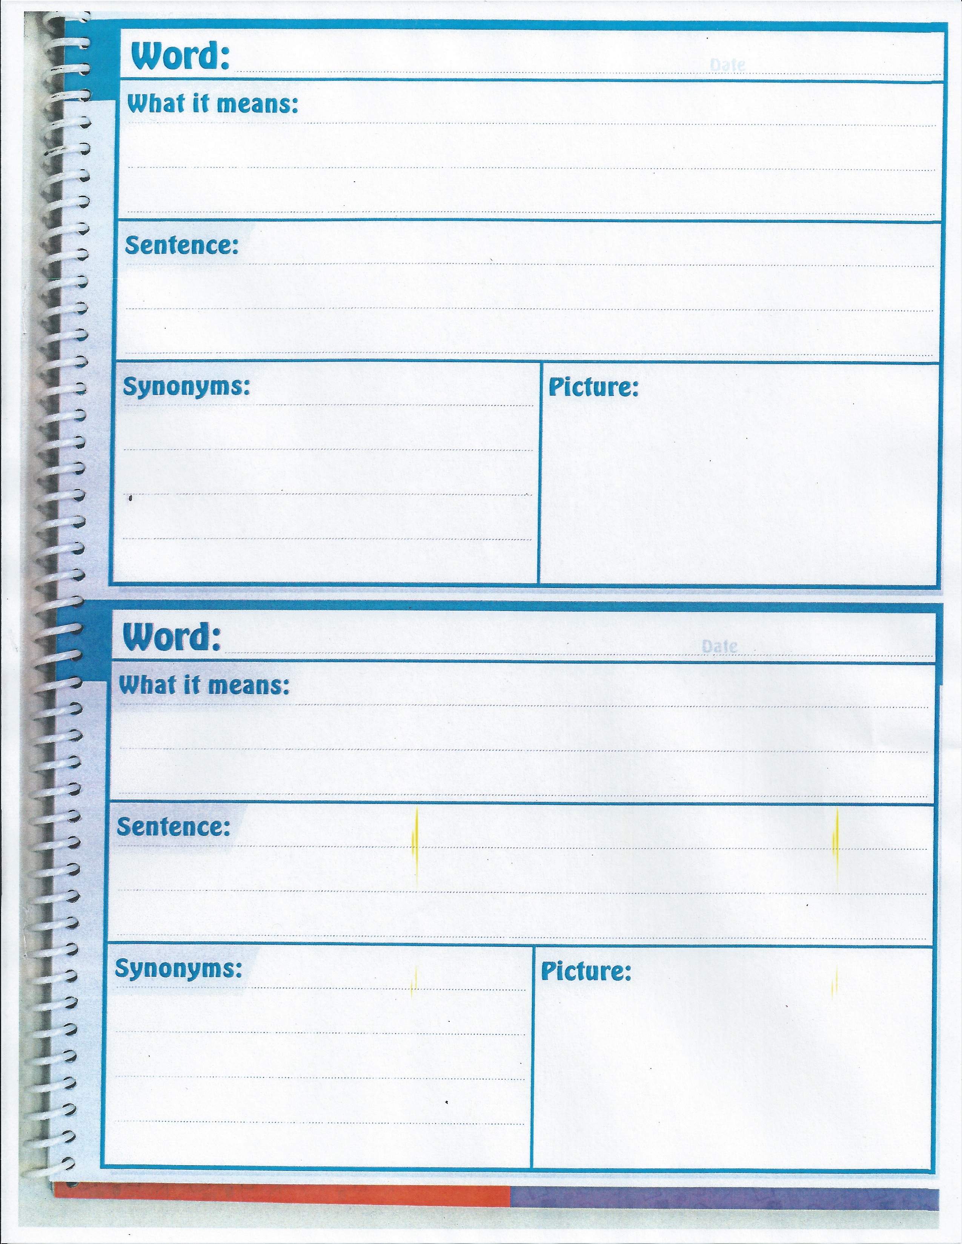

Alternatively, ELLs can also create their own personal flashcards to record vocabulary. On the back of each index card, the scholar can write the word/idiom in a sentence and/or write the word in their first language:

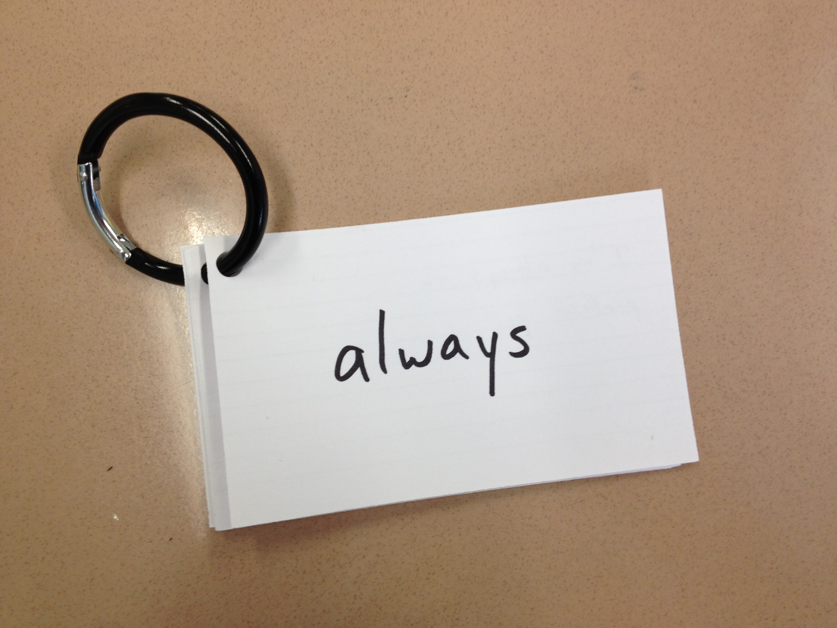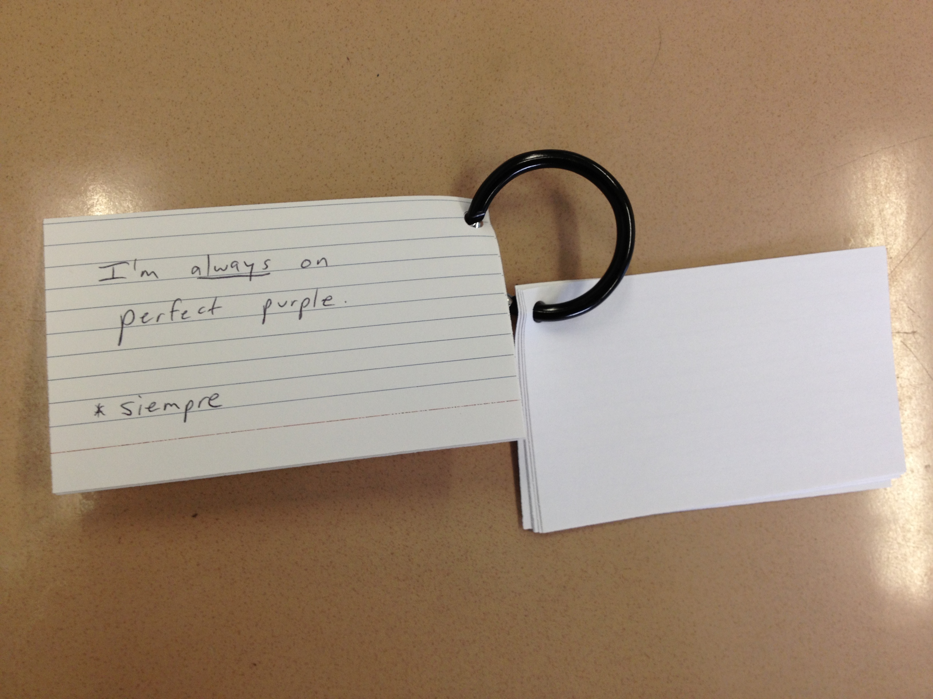

2. The Buddy System: During certain activities, seat a newcomer (an ELL who just arrived in this country) next to a responsible student who speaks their home language. This will allow the newcomer to keep up with the class (as long as the students are only discussing the schoolwork). However, please try to make heterogeneous groups as well: make sure the ELLs are also regularly mixed with non-ELLs when you group in order to expose them to English as well.

3. Even ELLs who have tested out of the NYSESLAT, or passed the NYSITELL or LAB-R, may still have reading and writing deficiencies. As the ESL teacher, I am providing my students with phonics and grammar lessons. If you have a former ELL, and I am not servicing them, they can still benefit from ELL strategies for extra support.

4. Students repeat key words chorally. I always have students repeat key words at least twice (the whole class). This gives ELLs an opportunity to try out the new language without being singled out. Point to focus attention on words or pictures that you are discussing during a minilesson. Once their attention is directed, have them chorally repeat the word(s) or name the picture.

5. Visuals and Realia. Use drawings, photographs, and videos to illustrate your point. Also, younger students or newcomers may draw their responses instead of writing if they are unable to write at the present time.
Bring in real objects (realia) to teach vocabulary words. If you’re teaching them what a globe is, show them a globe. If you’re teaching them about the solar system, bring in a model. If you’re teaching them about fool’s gold, have a replica on hand for them to handle.

6. Body language (Gestures) and TPR (Total Physical Response): Activities in which students respond physically to the teacher’s commands. (Simon Says, “Head, Shoulders, Knees, and Toes”, etc.) Kinesthetic activities: Name Wave from Tribes (may be used with vocabulary: for example, the names of animals.) Another example: Teaching the word small and having the students use their hands to show something small (what small looks like).
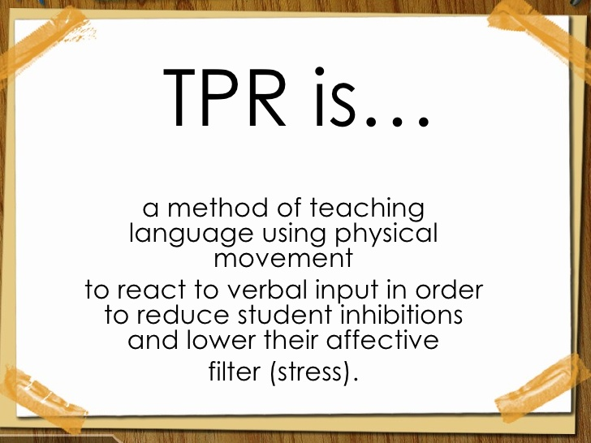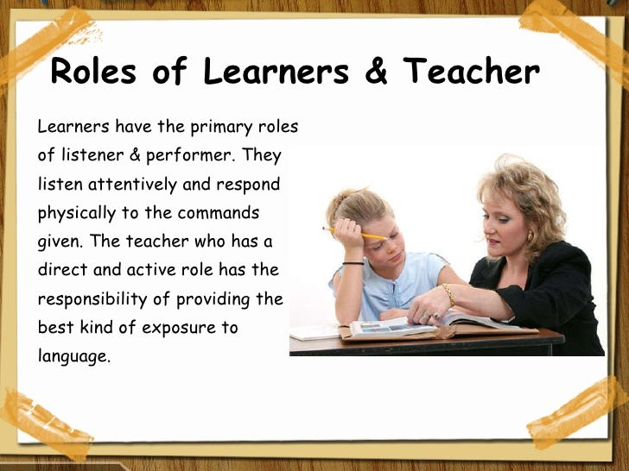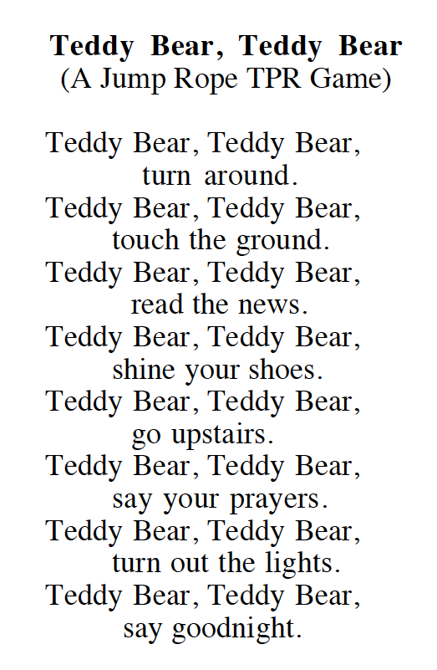

Total Physical Response (TPR) is a language teaching method built around the coordination of speech and action; it attempts to teach language through physical (motor) activity. Developed by James Asher, a professor of psychology at San Jose State University, California, it draws on several traditions, including developmental psychology, learning the­ory, and humanistic pedagogy, as well as on language teaching proce­dures proposed by Harold and Dorothy Palmer in 1925. Let us briefly consider these precedents to Total Physical Response.

Total Physical Response is linked to the "trace theory " of memory in psychology, which holds that the more often or the more intensively a memory connection is traced, the stronger the memory association will be and the more likely it will be recalled. Retracing can be done verbally (e.g., by rote repetition) and/or in association with motor activity. Combined tracing activities, such as verbal rehearsal accompanied by motor activity, hence increase the probability of suc­cessful recall.
In a developmental sense, Asher sees successful adult second language learning as a parallel process to child first language acquisition. He claims that speech directed to young children consists primarily of commands, which children respond to physically before they begin to produce verbal responses. Asher feels adults should recapitulate the processes by which children acquire their mother tongue.

7. Front load vocabulary that may give ELLs trouble during the lesson. Write the word on a sheet of paper accompanied by an illustration or photograph. Ask the students to chorally repeat the word twice. Another suggestion: for certain words, such as emotions, you can have students act out the word as they say it.

8. Kinesthetic activities: Have students move around the room or simply move their bodies.

A few examples:

If you are teaching about opinions, put a sign on one side of the room that says “I agree,” and a sign on the other side that says “I disagree.” Read a statement and ask the students to move. Ask those students to discuss why they agree or disagree. Share as a class.

Science: If you are teaching about circuits, have the students form a circle and join hands. Include a battery and a flashlight in your circuit. When the circuit is broken, the flashlight turns off.

Science: Teach about how the rotation of the Earth causes day and night by having a student stand by a light bulb/lamp (the Sun). Tell the class that this student is the Earth. When the student is facing the light, it is daytime. Then, tell the student to rotate slowly. When they are facing away from the light bulb, it is nighttime. You can also accomplish this by using a globe. You can also teach about how the revolution of the Earth causes the four seasons.

Sequencing: Teach about the sequence of a story. Photocopy 3-5 illustrations from a book: from the beginning of the book, the middle of the book, and the end of the book. Choose 3-5 students to figure out the order of the story. Each student will hold one illustration. The student holding the first event will stand at the far left of the classroom, and the student holding the last event will stand at the far right of the classroom. You can modify this activity depending on your class. Instead of pictures, you may give them sentences from the story. You may want to add the words First, Next, Then, After that, and Finally. You could add 3-5 more students to the mix and have them hold theses sequencing words. Ask the student with the picture/sentence to match up with the student who is holding the sequencing word that goes with their picture.

9. Role play. Role play a historical event during Social Studies.

10. Demystify Figurative language. A chart can be drawn with the literal meaning of a phrase vs. the figurative meaning of a phrase.

Literally  (Drawing)  Phrase: | Figuratively  (Drawing)  Phrase:  Really Means:

11. Give ELLs time. ELLs get time and a half on New York State exams. You might want to provide ELLs with extra time on tests. For more on testing, see #12 and #13 and #18.

12. When sharing out in a whole group situation, newcomers may want to use their Right to Pass. If they feel comfortable, ask them if they want to share in their home language. Even though they may have acquired basic communication skills in English (BICS), they may not be ready to use their academic language skills (CALP). On the other hand, there are certain ELLs who may not push themselves to practice their newly acquired English skills. Please encourage these ELLs to ask or answer questions in English.

13. In subjects such as Math, Social Studies, and Science, you may want to have an interpreter (e.g. an ed assistant or teacher who speaks Spanish or Bengali) translate the question/task being asked (barring, of course, English vocabulary questions). Google Translate is also a great resource. A Science exam should test the student’s knowledge of scientific principles, not the scholar’s English proficiency.

14. Allow ELLs, especially newcomers, to write their answers/essays in a mix of English and their home language (if they can write in their L1). Tell them to write as much as they can in English, and if they don’t know a word in English, try to write it in Spanish. If the ELLs cannot write in English yet, have them write in their first language, and as they learn English, have them integrate the words that they learn: Writing assignments, Social Studies, Science, etc.

15. Have them read in their home language as much as possible.
Research shows that “there is a strong transfer between a student’s primary language and the development of second language literacy” (Goldenberg, 2010).
In school and at home: students should be reading books in their first language, bilingual books, and English books at their level (and hopefully age-appropriate). If I haven’t already done so, I will provide each classroom with bilingual books and books in the scholars’ home languages. Please provide Spanish-speaking ELLs with a Spanish version of the textbooks you are using, if available. Use picture dictionaries. You can find picture dictionaries that target academic content areas. There are several Oxford Picture Dictionaries that are appropriate for children. In addition, the picture dictionary can be monolingual, especially if it is for a student in Pre-K or K.

16. Websites:
Here are some useful websites to put the scholars on whenever there is a chance:

http://www.schooltube.com/channel/havefunteaching/

http://www.brainpopesl.com/

http://www.starfall.com

Videos of Common Core Lessons for ELLs:
https://www.teachingchannel.org/blog/2014/07/18/common-core-lessons-for-ells-nea/

https://translate.google.com

If you have the Google Translate app on your iPad or iPhone, you can translate a page of text instantly.
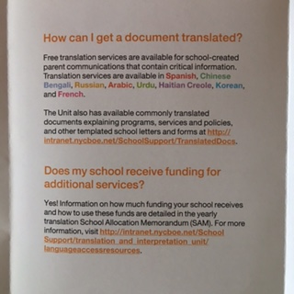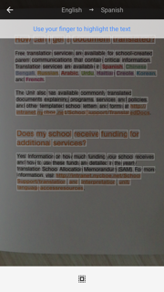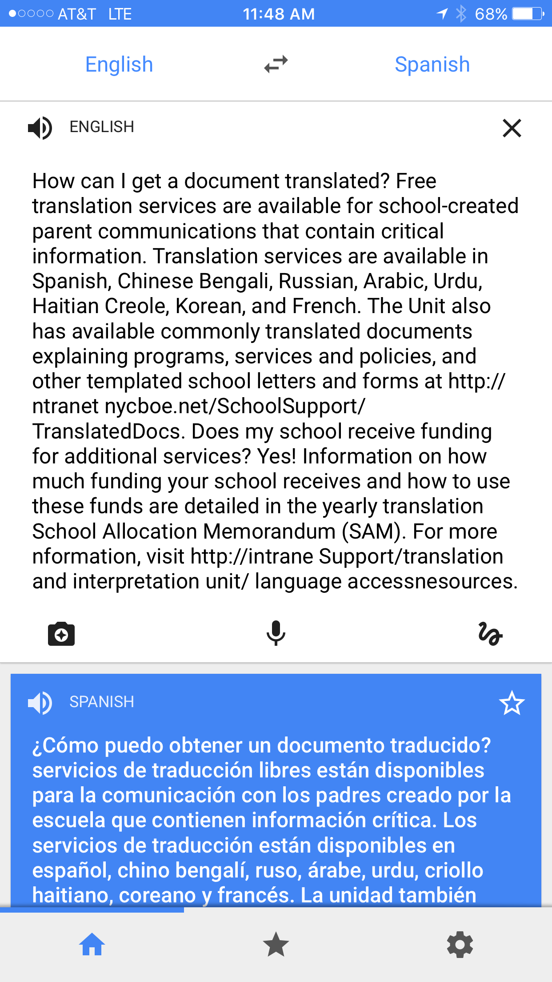
The original…. ….take a pic in GT…. …and it translates the text!

17. When sharing out in a whole group situation, newcomers may want to use their Right to Pass. If they feel comfortable, ask them if they want to share in their home language. Even though they may have acquired basic communication skills in English (BICS), they may not be ready to use their academic language skills (CALP).

18. When watching a video in class, watch with English captions/subtitles (if available).

19. Encourage the third, fourth, and fifth grade ELLs to use the NYC official bilingual glossaries and/or word-to-word translation dictionaries with which they were provided. These dictionaries are the ones that give direct word-to-word translation (ex. Spanish-English/English-Spanish dictionary). They may be used during lessons or on exams, unless you are testing their English vocabulary/spelling/grammar. Our ELLs will be permitted to use these dictionaries when they take the State ELA exam. During the State Math and Science exams, our ELLs will be allowed to have the test booklets in both languages (L1 and L2) on their desks, but must choose only one to write in. If their home language is not provided in translated written form, we will provide them with an interpreter.

20. If you speak an ELL’s language, you can use it when all else fails. If an ELL is completely lost, especially at the beginning of the school year, translate key vocabulary words and help them understand the main idea of your minilesson. After you translate a vocabulary word into their L1, have the student repeat the new word in English. Ask the ELL to include the word in their individual writing assignment, even if the majority of it is in their home language.
21. Have sentence starters and common questions posted in your classroom.

Examples:

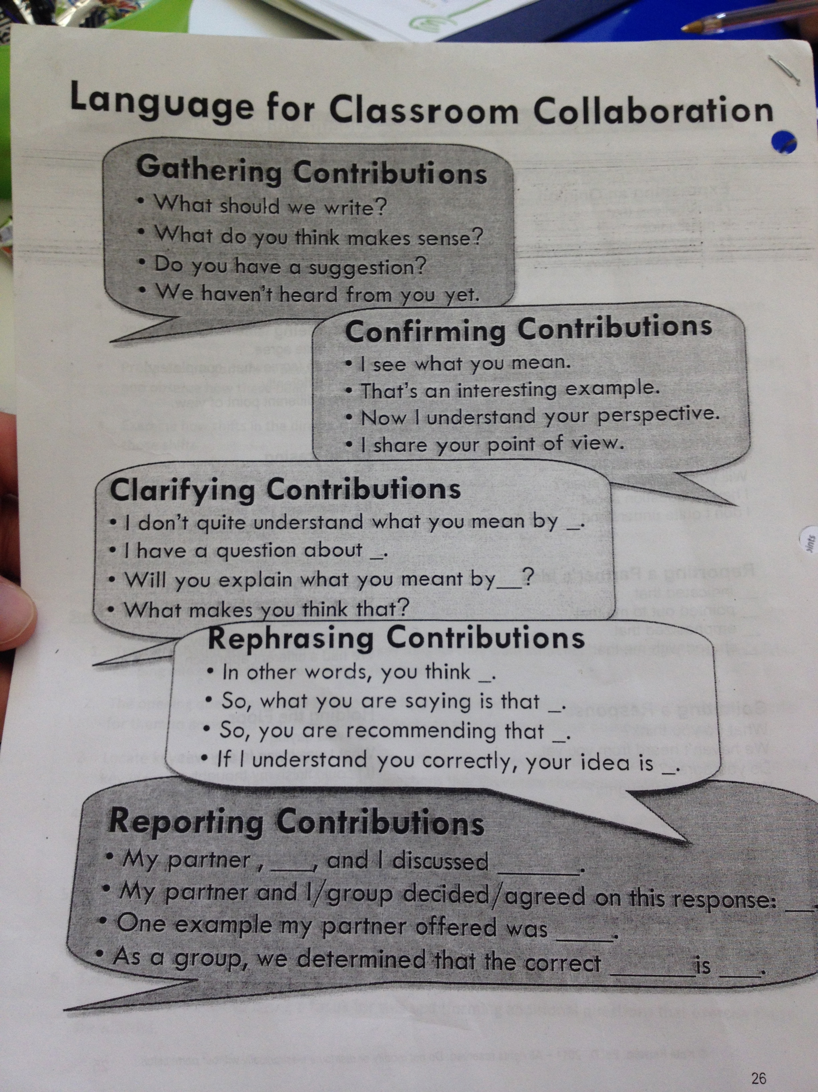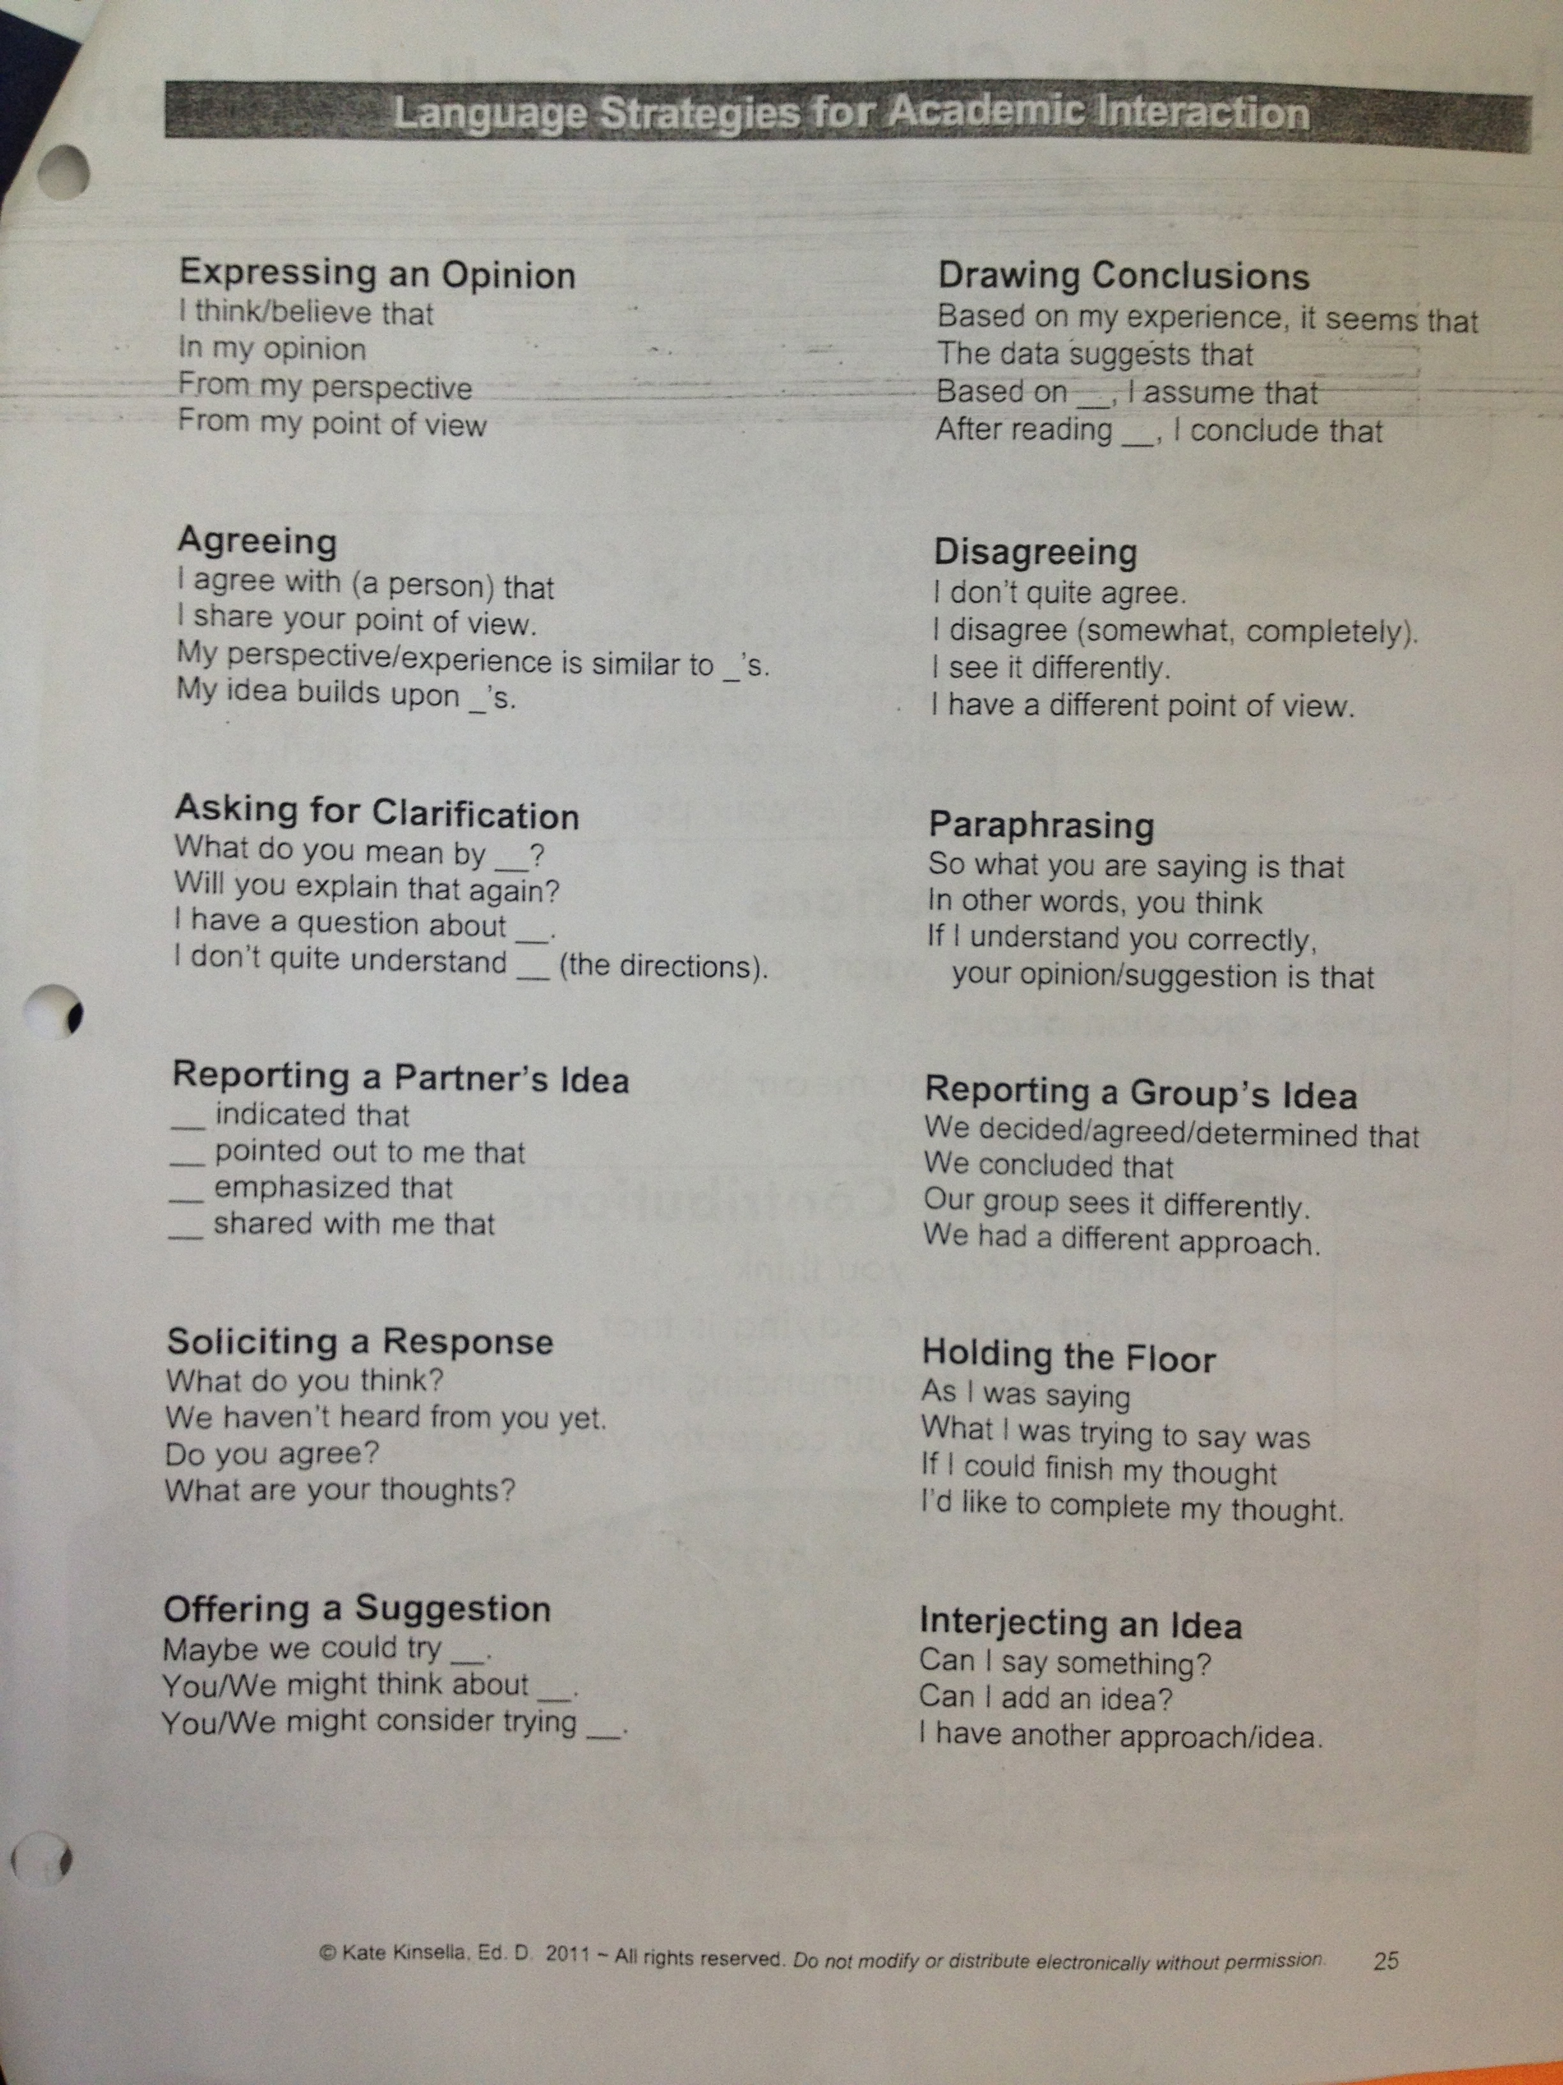

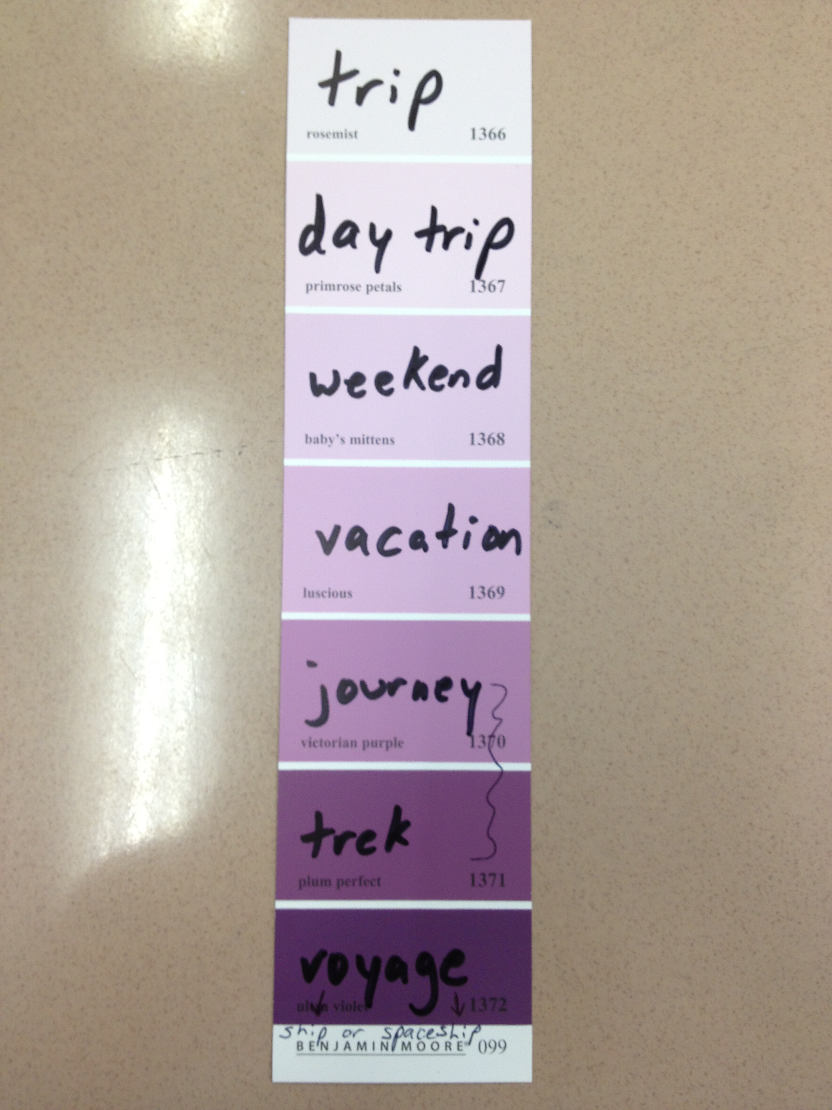
22. Create linear arrays.

Linear array: A vocabulary word may have synonyms, but what is the intensity of those synonyms? Big, huge, gigantic, enormous, humongous – all of these words mean big, but they have different intensities and create different images in one’s mind.

23. Have a structure in place for short answers/writing paragraphs. Here is an example in both English and Spanish.
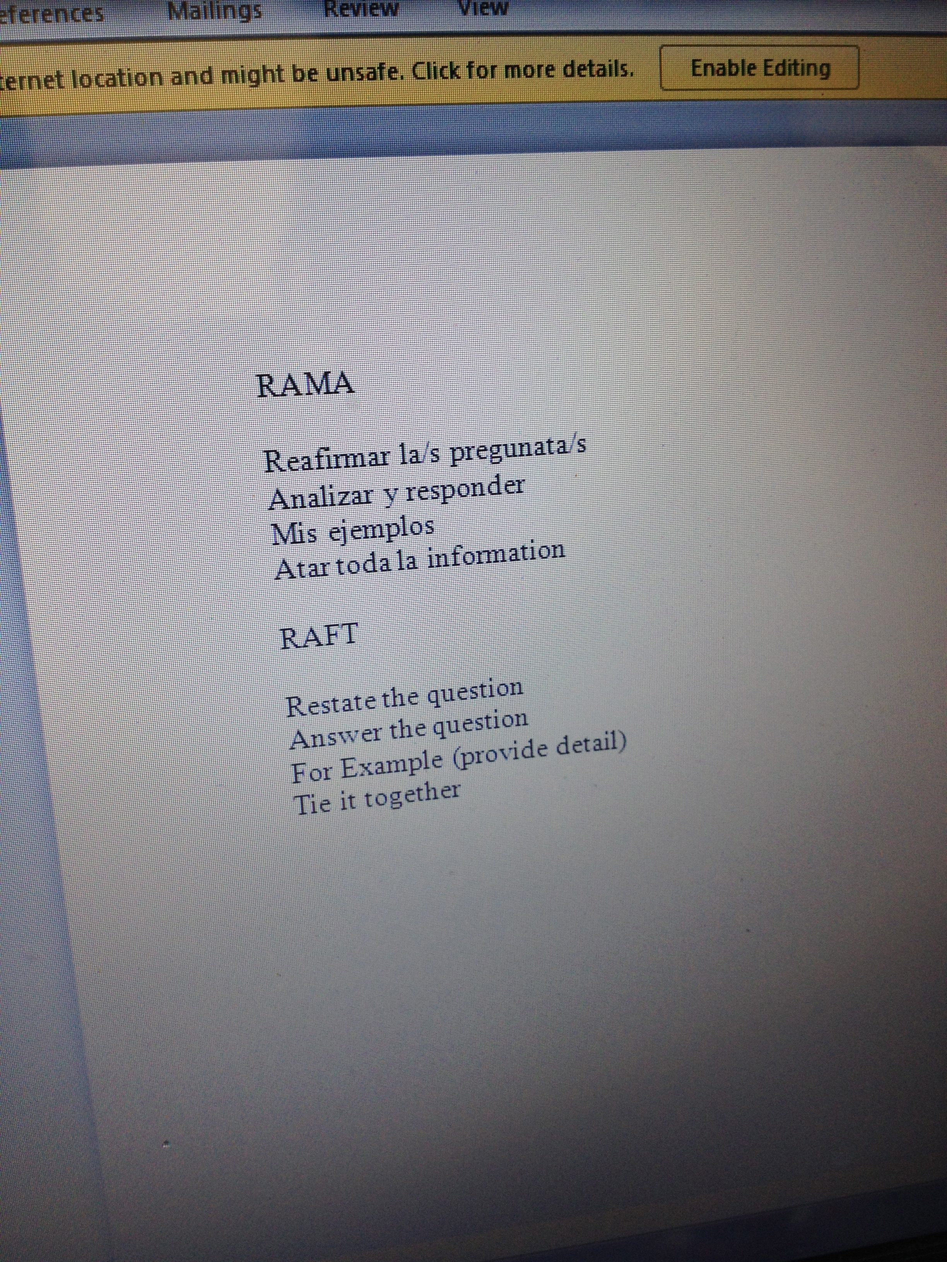

24. Especially in lower grades, focus on blends, digraphs, and vowel sounds. Certain digraphs such as th, sh, and ch may be difficult for ELLs. The vowel sounds in English may be different from the vowel sounds in their L1. Help ELLs find the correct shape/placement of their mouth and tongue to form these sounds.

25. If you have newcomers in your class, and I have provided you with a headset, please allow those scholars to use Rosetta Stone at least once a day for about 20 minutes. I have provided you with instructions, but if you need additional help, please don’t hesitate to ask! The website is: enyese.rosettastoneclassroom.com

26. Sentence starters/Sentence frames: These are helpful for giving ELLs a tangible way of starting a conversation or answering a question. They may be differentiated for their English level.

For example:

Beginning (Entering): I like to eat ___________.
Intermediate (Emerging/Transitioning): I like ____________, but I don’t like ___________.
Advanced (Expanding): In my opinion, ___________ are better than _________, because ___________________________.

For another example, see the following page….

Another example:
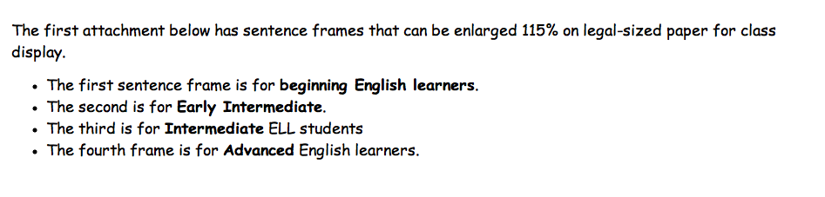

Compare and Contrast

Compare = similar (the same) | Contrast = different

1….______ and ________ are ________________.

2… Both _____ and _____ have _____________.

3….__and __ are both similar because they both ____.

4….There are several major differences between ___ and ___.
The most notable is ____________, because ______________________________________.

27. When we construct worksheets, instructions, or charts, we make sure we can reach even the newest ELLs. Visuals, color-coded, organized, etc….

Example:

Are you a boy?
Are you a girl?

------------

Do you have brown hair?
Do you have blonde hair?

------------

Do you have blue eyes?
Do you have brown eyes?

------------
Are you short?
Are you tall?

Are you wearing shorts?
Are you wearing pants?

28. With newcomers, I routinely teach and review letter sounds, blends, digraphs, diphthongs, etc.

29. Music and lyrics: Many students learn information well if it is in the form of a song, rap, or poem. When teaching the song, use visuals or realia to teach the meaning of the lyrics. You may want to add gestures to the song to aid with comprehension and retention.

30. A couple of years ago, I attended a PD about best practices for teaching ELLs. Among their key principles, they listed:
1. Frontload vocabulary
2. Strengthen ELL’s L1 to help them transfer skills to English
3. Teach through songs
4. A lot of repetition is important
5. Visuals/Images are key
6. Reading in “little chunks” instead of presenting a full page of text (which can be overwhelming)
7. Vocabulary in a student’s L1 matters, too, to build their skills and to successfully transfer them to English
8. Bilingual students are more attentive and aware of text features and words
9. Constant checks for understanding

31. Here is a list of scaffolds in math from the NYCDOE Department of ELLs.
Explicit Support for English Language Learners
Scaffolds and Resources:
Strategies Specific to English Language Learners
- Total physical response (TPR) is a language-learning method based on the coordination of speech and action. It was developed by James Asher, and it is linked to the trace theory of memory, which holds that the more often or intensively a memory connection is traced, the stronger the memory will be. Language is learned best through action.
- Vocabulary and language development: Teachers introduce new topics by discussing key vocabulary words. When introducing fractions, they must begin with a discussion that taps into students’ prior knowledge.
- Cooperative learning/group work allows students to work together and engage with a mathematical concept through peer interaction and support. Cooperative learning helps develop key literacy for ELLs (Reading, Writing, Speaking, and Listening) through the content area of mathematics.
- Visual aids provide clues and context. In the classroom, visual aids provide sensory support students can refer to as needed. Pictures, diagrams, and charts make the content more accessible. Procedures can be shown with picture clues or listed on the board.
- Cognates are words that are similar in two languages. The teaching of cognates is one of the most effective methods of instruction for English learners.
- Metacognition involves teaching the student to think about the thinking process. To teach metacognitive skills, the teacher must model the thinking processes as he/she works toward solving a problem and asks students to do the same.
- Authentic assessments provide for the application of mathematical concepts and skills. Different activities with real-life applications must be used to assess learners. The formative assessment (exit slips) is key to checking daily for understanding.
- Sufficient wait time allows English language learners additional wait time after a question is posed. This additional time is needed for ELLs to translate the question into their native language (L1) and then translate their response back into English. Incorporating this additional time into the instruction will help reduce any anxiety associated with learning in a non-native language. Another highly effective strategy is to give ELLs advance notice of the questions they will be expected to answer. This provides them with time to develop their responses and supports their learning. For example, you might tell Jose that he will be asked to respond to a question after another student has given his/her response. This will give Jose extra time to process and formulate a response.
- Explicit instruction is essential. Direct teaching of academic language, concepts, and skills is necessary to ensure ELLs receive coherent, scaffolded, and seamless instruction.
- Real-world contexts and relevant themes allow the learner to connect with the content in a way that is engaging and applicable to the student. Themes that appeal to students will generate interest and motivate them to learn more effectively.
- Modeling, graphic organizers, and the use of a variety of visual aids, including pictures, diagrams, and charts, helps all students—especially ELLs. It allows them to easily recognize essential information and its relationship to supporting ideas. Visuals make both the language and the content more accessible to students.
- Change speech patterns to focus students’ attention. Slow down your rate of speech. Pause. Check often for comprehension. Ask students, “Do you understand? Thumbs up for yes; thumbs down for no.” This provides a way for ELLs to let you know whether you need to adjust your delivery without having to request it outright.
- Enunciate words. Speak clearly. Use intonation. Emphasize or exaggerate important vocabulary.
- Write key concepts on the board. When possible, use different colors and fonts to highlight key concepts.
- Partner ELLs with strong English speakers or bilingual speakers.
- Encourage participation. Students come from countries with different social mores and cultures. They may feel shy or embarrassed to speak to other children, or even to adults.
- Hands-on activities provide for a tactile learning experience. They address the needs of the kinesthetic learner. The physical, hand-on act reinforces the mathematical reasoning, and it supports speaking and listening skills.
- Make sure directions are clear. Write the directions on the board or a chart for students to refer to.
- Create a math word wall. This provides students with a concept timeline on the wall. Students can refer to the word wall at any time. Words that are accompanied by pictures or illustrations are even more effective.

English immersion with some native language support:

Rationale for using native language support:
A number of years ago, I researched the effectiveness of several ELL programs. I found that transitional bilingual programs always have an ESL component: “[ESL is a] crucial component of all bilingual programs” (Collier et al, 2003: 73). They go hand in hand. More importantly, according to my research, bilingual programs have been proven to be more effective than pure English immersion. Pure English immersion is equal to the sink or swim approach, which goes against everything I have ever learned. Even when I was immersed in the Portuguese language in Brazil, I needed my bilingual dictionary and I needed my friend who spoke English to clarify things. Also, if I hadn’t learned French, I wouldn’t have been as successful at learning Portuguese. I transferred those skills over to my Portuguese education.

Limited-English-proficient students who are provided with substantial instruction in their primary language (40%) successfully continue to increase their achievement in content areas such as mathematics, while they are acquiring their skills in English; in contrast, students who are quickly transitioned into English-only instruction tend to grow slower than the norming population. (Ramirez et al, 1991: 39)
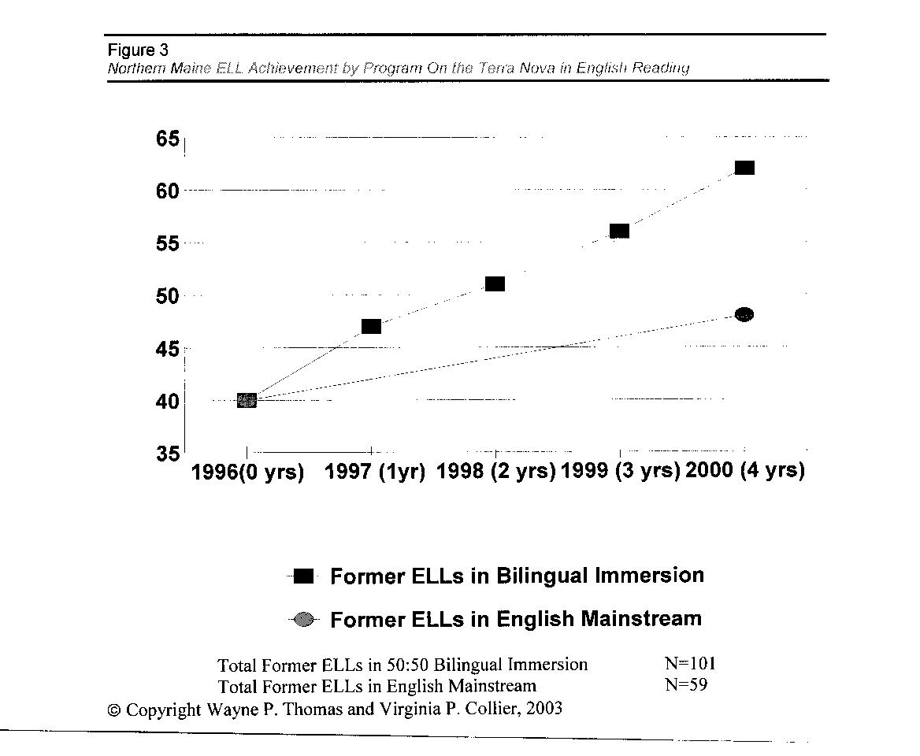

Tatiana Sevillano…. moved to the United States knowing only Spanish when she was eight years old
(Tapia, April 10, 2000). Tatiana was first placed in a mainstream (English-only) classroom. She felt
disconnected, isolated, scared, shy, timid, and intimidated (Tapia, April 10, 2000). After she was placed
in a bilingual classroom, she found that it was “easier to learn” because she didn’t feel as intimidated
(Tapia, April 10, 2000).
According to Susan Black (2005), a 2002 UCLA study of ELLs in California schools found that
“English-only programs ‘predict a very dismal future’ for large numbers of elementary-age students”
(page 40).

Research shows that “there is a strong transfer between a student’s primary language and the development of second language literacy” (Goldenberg, 2010).

Through the past 15 years of experimenting with different methodologies and strategies, I’ve discovered that supporting ELLs in their native language actually moves them along quicker and further in the long run, gives them confidence along the way, lowers their frustration, and maintains and strengthens their L1 and L2 literacy.

I’m a firm believer that ESL doesn’t need to be pure English immersion. In fact, according to the Office of English Language Learners, ESL programs actually require native language support. The official video that we show to parents of new ELLs at our parent orientation explains that ESL “[provides] instruction in English with support in students’ home language.” Although instruction is presented in English, only key concepts are often clarified in the student’s main language (Echevarria et al, 2013).

Certain newcomers cannot yet communicate or read in English, so providing an ESL scaffold may not be enough to make content comprehensible at the present time. I provide the newcomers in grades 2-5 with supplemental work packets / alternative homework to build up their BICS and Tier 1 vocabulary.

I believe teachers should use every tool at their disposal, and that may include the use of native language supports. Oftentimes, teachers in the upper grades may give newcomers a translated version of the same passage the other students are reading in order to a) teach a new reading strategy, b) give newcomers the opportunity to work on and develop their reading comprehension, and c) give the newcomers confidence. It has been argued that literacy can be developed in a student’s L1, and those reading skills can then be transferred to their L2 (August & Shanahan, 2006). These students should be provided with independent reading books on their English reading level, as well as books in their L1 to foster bilingual literacy. Teachers should be using other supports as well, such as visuals, body language, choral repetition, etc.

Students who cannot write in English yet (often newcomers) should still be writing when the others are. If they can write in their L1, you may want to translate the prompt and tell them to write in their native language and try to integrate as many English words as they can. Pair them up with a bilingual student who can help them add English words to their writing. If the student can speak some English, ask them to interpret their writing as well as they can and tell you what it says in English. Add certain English words to their writing that they were able to tell you in English. Or, ask another bilingual student to interpret what it says. Then, tell the newcomer a couple of key vocabulary words that they could have used in their writing. This way, they can learn the skill or strategy being taught, they can be included in the class assignment, and they can increase their English vocabulary.

The ELLs will be allowed to use bilingual dictionaries (word-to-word translations only) on the ELA exam, and will receive translated or interpreted versions of the Math and Science exams, so some bilingual support in content areas may be useful.

Although we may use native language support, we should also limit the amount of native language support, and not let it get in the way of whole class instruction. Work should be differentiated, and at times, this may include some translation or interpretation.

Classroom Environment
*Place labels around your room:
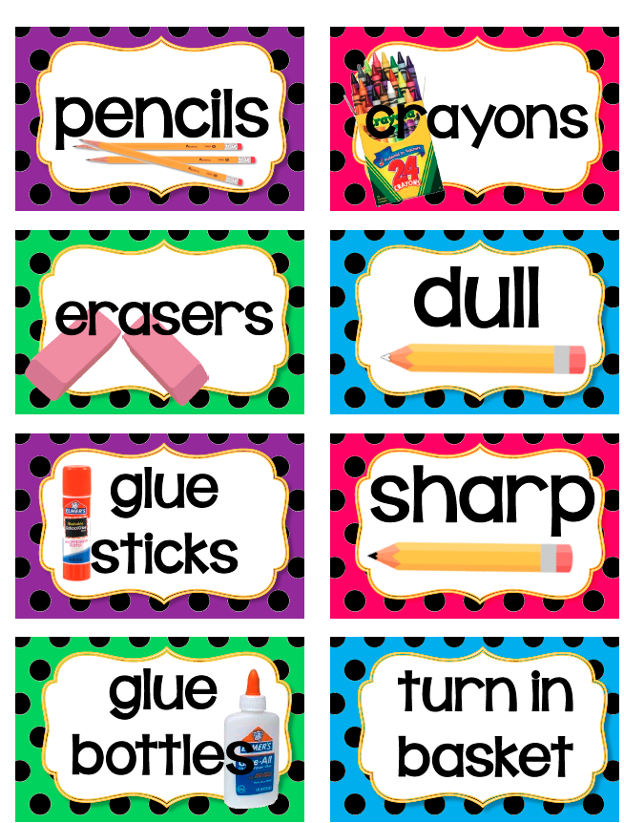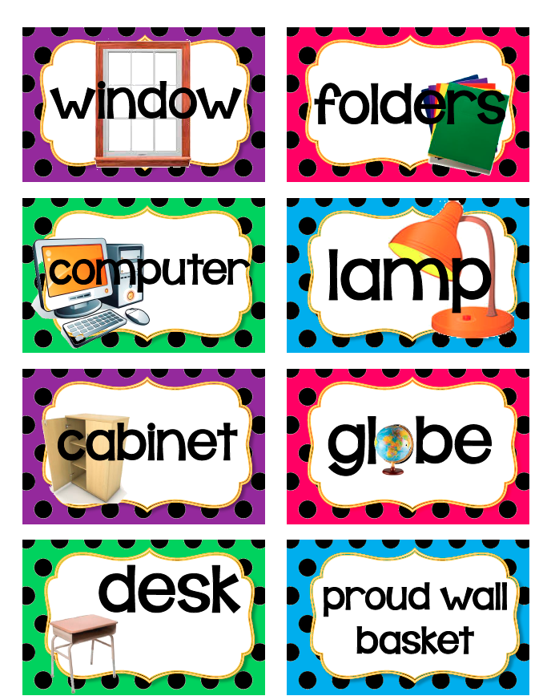

* Make your word walls visual:
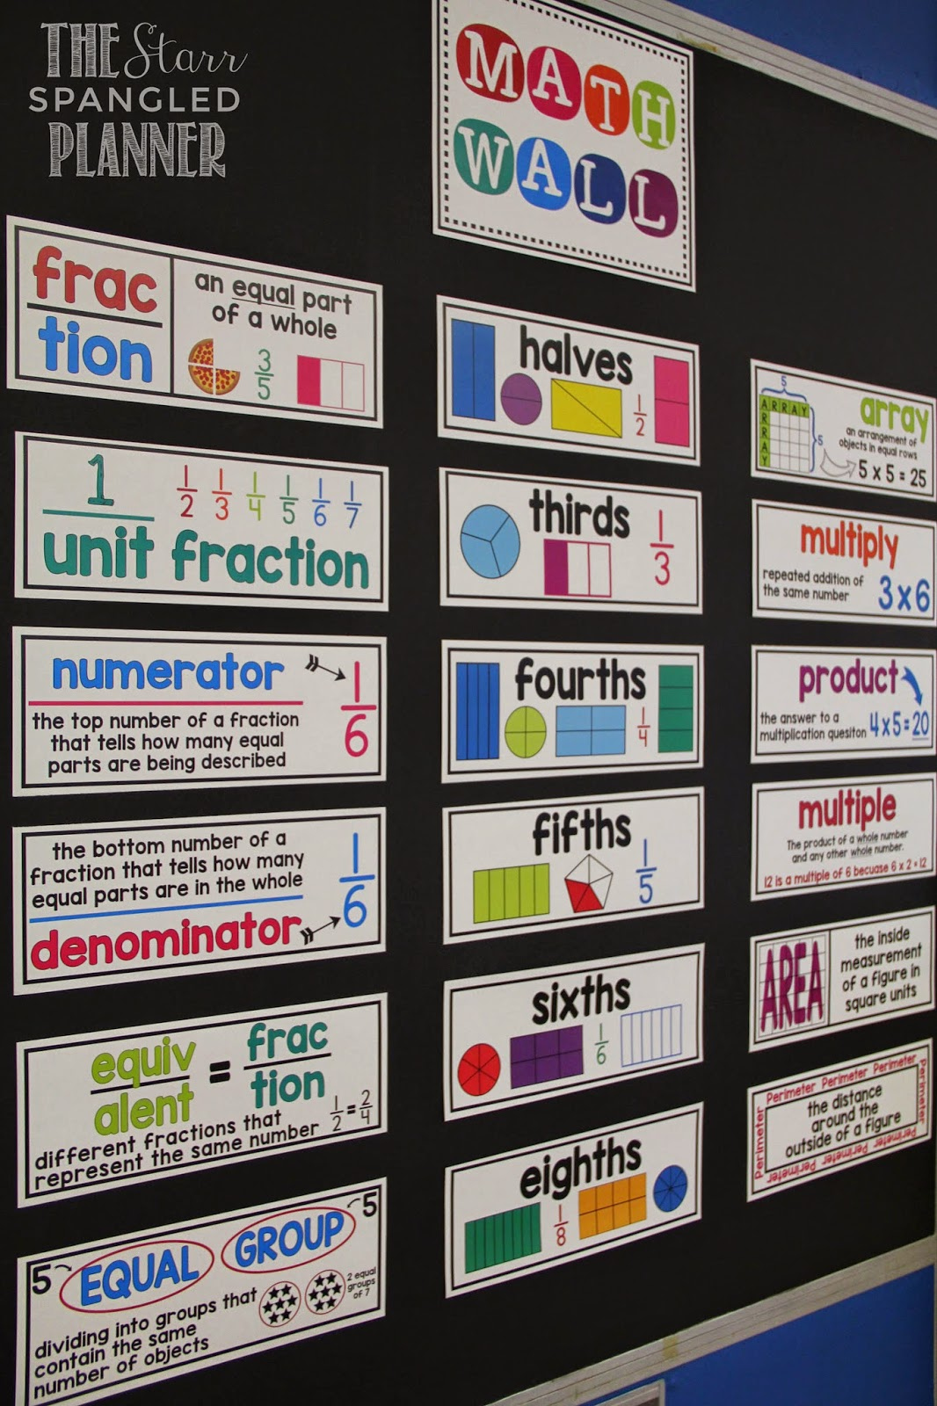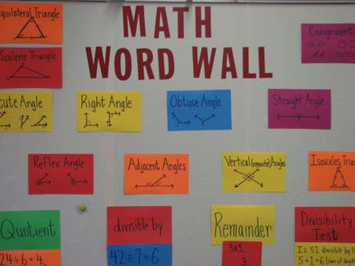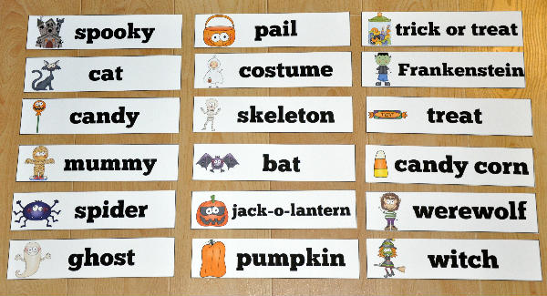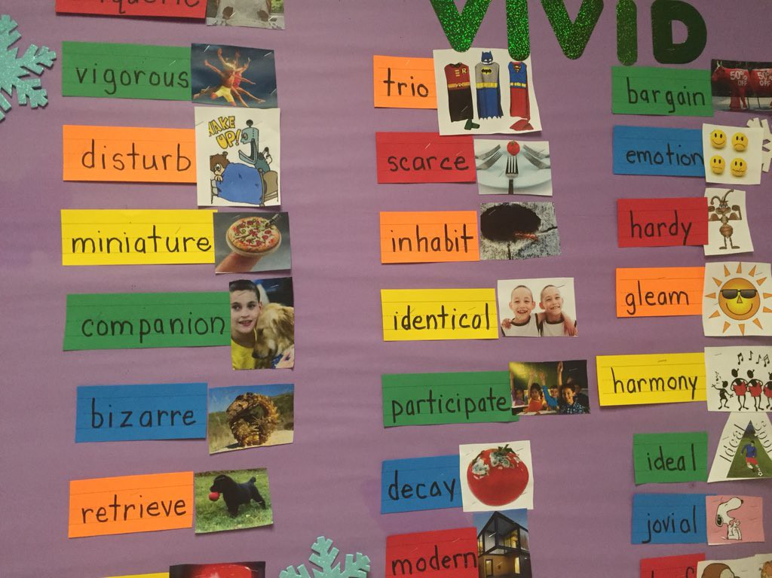

THE THEORY BEHIND THE STRATEGIES

The SIOP Model

In the SIOP model, the structures of the English language are taught through subject matter. There is a Content Objective AND a Language Objective.

Building Background
1. Concepts should be directly linked to students’ background experience. This experience can be personal, cultural or academic.
2. Links should be explicitly made between past learning and new concepts.
3. Key vocabulary is emphasized. New vocabulary is presented in context. The number of vocabulary items is limited.
KWL Charts; Introduce vocabulary with the use/support of realia, photos, illustrations, or videos; etc.

Comprehensible Input
Scaffold to make information clear.
1. Use speech that is appropriate for students' language proficiency.
2. Make the explanation of the task clear using step-by-step manner with visuals.
3. Use of a variety of techniques to make content concepts clear. Teachers need to focus attention selectively on the most important information. Introduce new learning in context. Help students learn strategies such as predicting, summarizing.
Strategies
1. Provide ample opportunities for students to use learning strategies. Learning strategies should be taught through explicit instruction. You want students to develop independence in self-monitoring.
2. Consistent use of scaffolding techniques throughout the lesson. Introduce a new concept using a lot of scaffolding and decrease support as time goes on. Restate a student's response or use think-alouds
3. Use of a variety of question types, including those that promote higher level thinking skills.
Interaction
Provide the following for ELLs:
1. frequent opportunities for interactions about lesson concepts which encourage higher level thinking skills.
2. grouping which supports language and content objectives. Cooperative groups, buddies, pairs, large and small groups
3. ample wait time for responses
4. opportunities for clarification in native language, if possible.

Application
Lessons should include:
1. hands-on materials or manipulatives for student practice.
2. activities for students to apply content and language knowledge in the classroom.
3. activities that integrate all language skills :listening, speaking, reading and writing.
Lesson Delivery
1. Content objectives supported by lesson delivery.
2. Language objectives supported by lesson delivery.
3. Students engaged 90% to 100% of the period.
4. Pacing of the lesson appropriate to students’ ability level.

According to the Office of English Language Learners (OELL), the key principles for ELL instruction are:

1. Instruction focuses on providing ELLs with opportunities to engage in discipline- speci!c practices
which are designed to build conceptual understanding and language competence in tandem.
Learning is a social process that requires teachers to intentionally design learning opportunities that
integrate reading, writing, speaking, and listening with the practices of each discipline.

2. Instruction leverages ELLs’ home language(s), cultural assets, and prior knowledge. ELLs’ home
language(s) and culture(s) are regarded as assets and are used by the teacher in bridging prior knowledge
to new knowledge, and in making content meaningful and comprehensible.

3. Standards-aligned instruction for ELLs is rigorous, grade-level appropriate, and provides deliberate and
appropriate scaffolds. Instruction that is rigorous and standards-aligned reflects the key shifts in the CCSS
and NGSS. Such shifts require that teachers provide students with opportunities to describe their reasoning,
share explanations, make conjectures, justify conclusions, argue from evidence, and negotiate meaning from
complex texts. Students with developing levels of English proficiency will require instruction that carefully
supports their understanding and use of emerging language as they participate in these activities.

4. Instruction moves ELLs forward by taking into account their English proficiency level(s) and prior
schooling experiences. ELLs within a single classroom can be heterogeneous in terms of home
language(s) proficiency, proficiency in English, literacy levels in English and student's home
language(s), previous experiences in schools, and time in the U.S. Teachers must be attentive to these
differences and design instruction accordingly.

5. Instruction fosters ELLs’ autonomy by equipping them with the strategies necessary to comprehend
and use language in a variety of academic settings. ELLs must learn to use a broad repertoire of
strategies to construct meaning from academic talk and complex text, to participate in academic
discussions, and to express themselves in writing across a variety of academic situations. Tasks must be
designed to ultimately foster student independence.

6. Diagnostic tools and formative assessment practices are employed to measure students’ content
knowledge, academic language competence, and participation in disciplinary practices. These
assessment practices allow teachers to monitor students’ learning so that they may adjust instruction
accordingly, provide students with timely and useful feedback, and encourage students to re! ect on their
own thinking and learning.

