Starry Messenger  by: Peter Sis  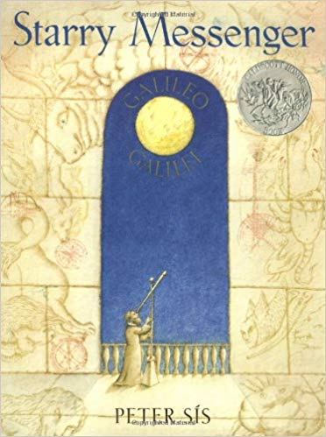  After exploring the book……  I notice: ____________________  ___________________________  ___________________________  I wonder: __________________  ___________________________  ___________________________  Moonshot  by: Brian Floca  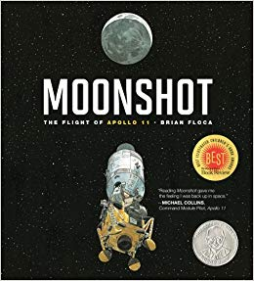  After exploring the book……  I notice: ____________________  ___________________________  ___________________________  I wonder: __________________  ___________________________  ___________________________ | One Giant Leap  by: Robert Burleigh  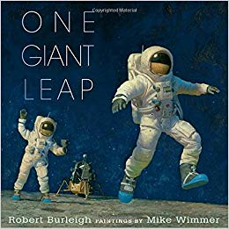  After exploring the book……  I notice: ____________________  ___________________________  ___________________________  I wonder: __________________  ___________________________  ___________________________  Starfield  by: Vija Celmin  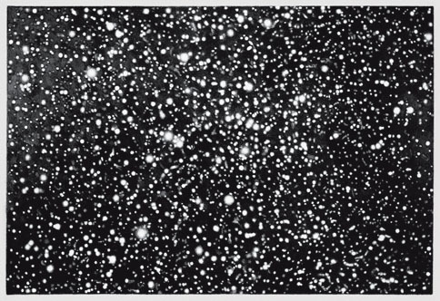  After exploring the book……  I notice: ____________________  ___________________________  ___________________________  I wonder: __________________  ___________________________  ___________________________ | Book and Art Tasting  Module 2: How do people learn about space?  Astronaut: ___________________________  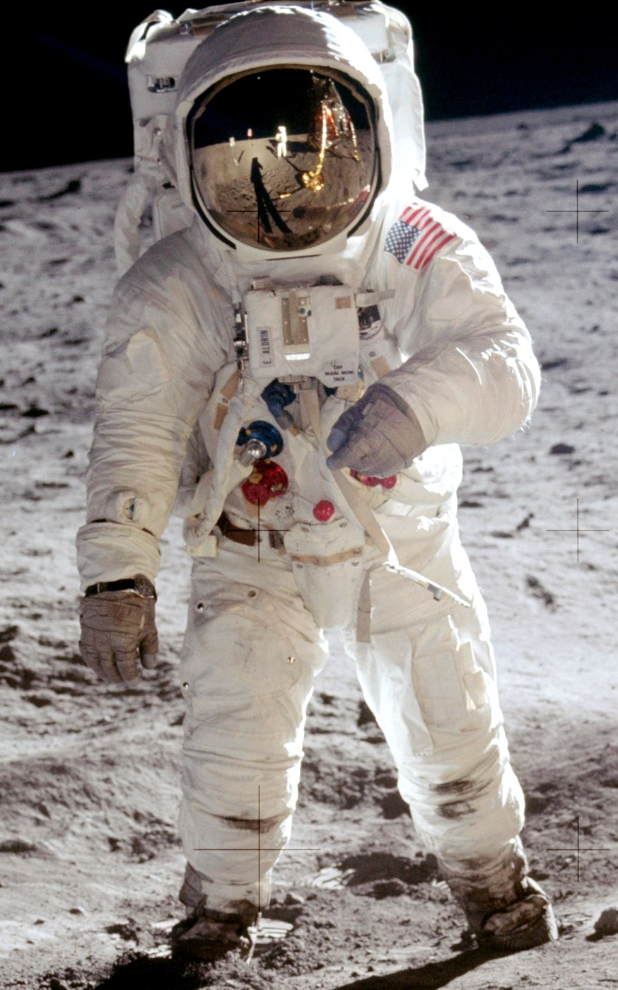  Zathura  by: Chris Van Allsburg  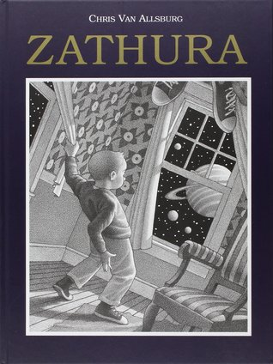  After exploring the book……  I notice: ____________________  ___________________________  ___________________________  I wonder: __________________  ___________________________  ___________________________

